Moqups wireframe for IT Project

1. Wireframe of index.html

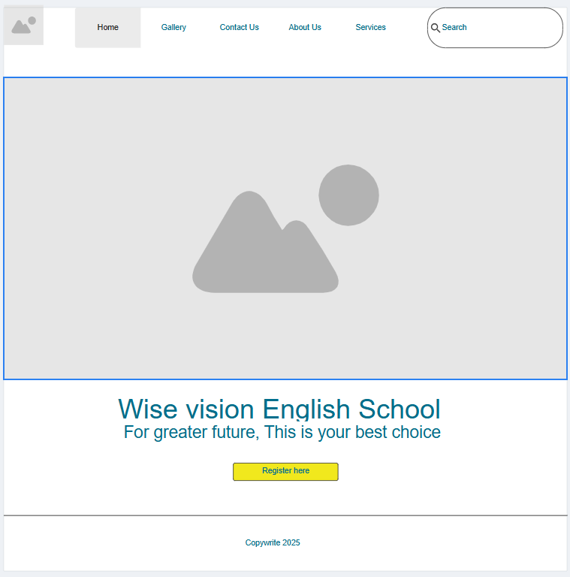

1. Wireframe of Gallery.html

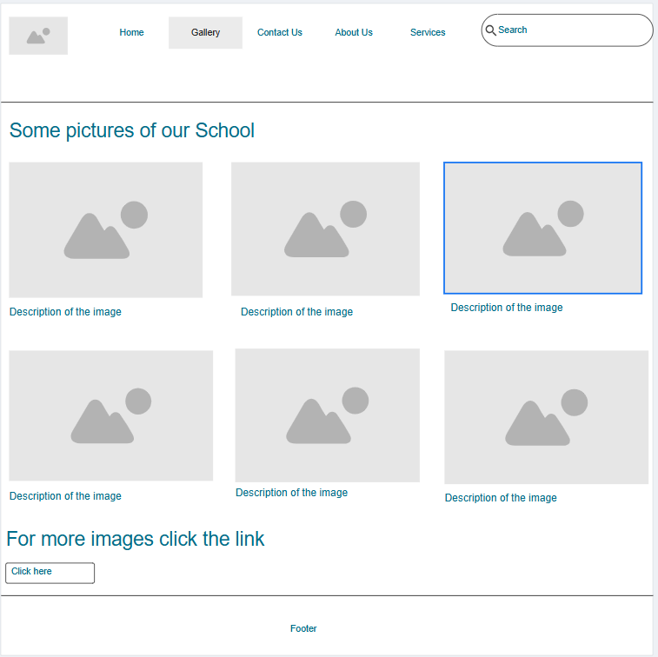

1. Wireframe of Contact Us.html

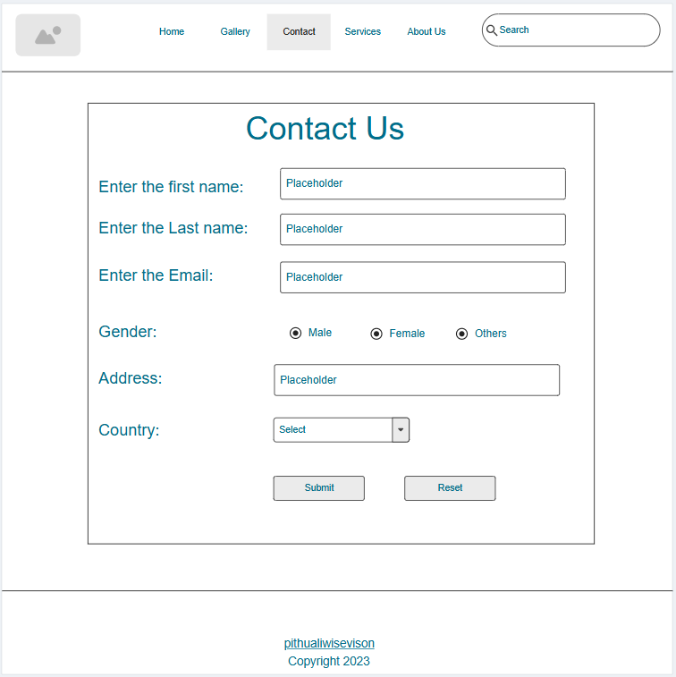

1. Wireframe of About us.html

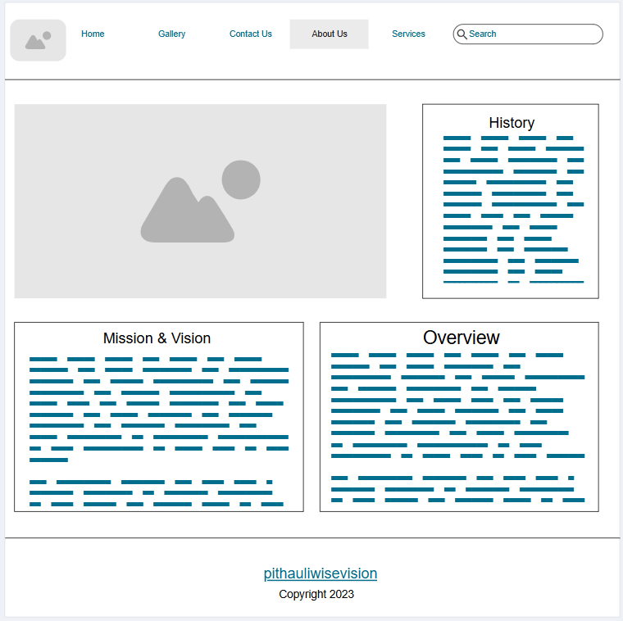

1. Wireframe of Services.html

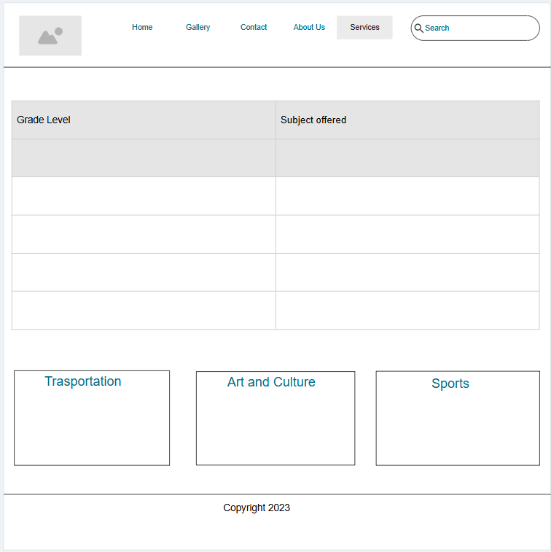

Link of Moqups : <https://app.moqups.com/lW6uXSc0oE80uEcISoPG0RRrftC422fy/view/page/ada6721fa>